**BASIC WORD ORDER IN ENGLISH**

***Subject + verb***

*In English, we normally need to* ***include*** *the* ***subject*** *in a* ***sentence****.*

*The* ***subject goes before the verb****:*

*We dance.*

*She is waiting.*

*We use* ***it*** *or* ***they*** *as subject, to talk about something that we* ***mentioned******before:***

*I like your guitar. It is nice. (NOT ~~I like your guitar. Is nice~~.)*

*Can you see those trees? They are beautiful. (NOT Can you see those trees? Are beautiful.)*

*We* ***don’t include the subject in imperative sentences****:*

*Sit down, please.*

*Call me soon.*

*We can put an* ***adverb of frequency*** *between the* ***subject*** *and the* ***verb****.*

***BUT*** *adverbs of frequency* ***go after*** *the verb when the verb is* ***be****:*

*We often dance.*

***BUT****: You are always late.*

***Verb + object***

*When there is an object in the sentence, we need to put it after the verb.*

***Verb and object are together****:*

*I like pizza very much. (NOT I like very much pizza.)*

*She plays the guitar every day. (NOT She plays every day the guitar.)*

***Place + time***

*We normally say ‘****where’*** *and ‘****when’*** *something happens in this order.*

***First ‘where’, and then ‘when’:***

*She arrives at the hospital in the morning. (NOT ~~She arrives in the morning at the hospital~~.)*

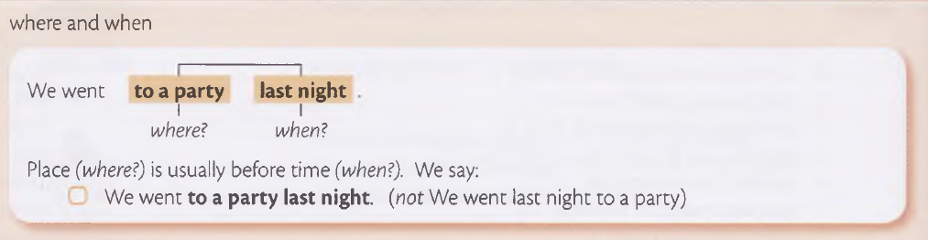*Will you be in the office at 3 pm? (NOT ~~Will you be at 3 pm in the office?~~)*

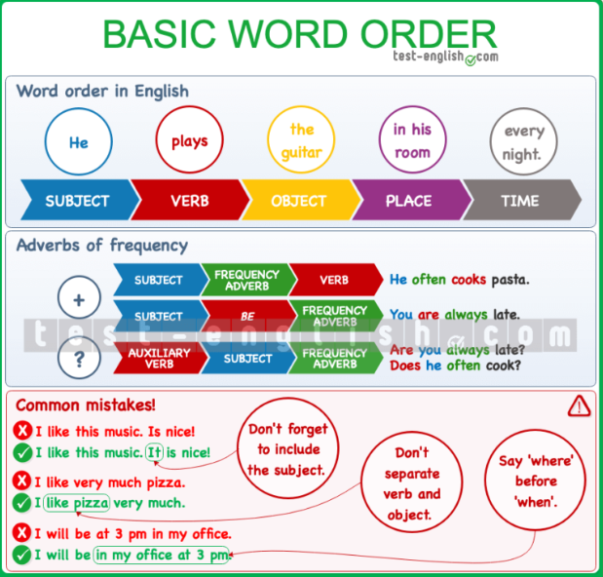***SUMMARY CHART***

**ADVERBS OF FREQUENCY**

*We use* ***adverbs of frequency*** *with the present simple to talk about* ***how often*** *something* ***happens.***

***Position***

*Adverbs of frequency go****before the verb****, but****after****the verb****be****.*

*In* ***negative sentences*** *the adverb of frequency goes* ***after don’t/doesn’t****:*

*We don’t often go to bed late.*

*He doesn’t always agree with me.*

*In****questions****, adverbs of frequency go* ***after the subject****:*

*Is he always late?*

*Do they often go to the library?*

***never/hardly ever***

*The adverbs* ***never*** *and* ***hardly ever*** *(===almost never) have a* ***negative meaning****, but they are used with a positive verb:*

*He is never late. (NOT ~~He isn’t never late~~.)*

*They hardly ever go to the library. (NOT ~~They don’t hardly ever go to the library~~.)*

***Expressions of frequency***

*There are other expressions that we use to talk about frequency:* ***once a day, twice a week, three times a month, every day****, etc.*

*These expressions are longer (2 words or more) and they* ***go at the end of the sentence:***

*I brush my teeth three times a day.*

*I see her every day.*

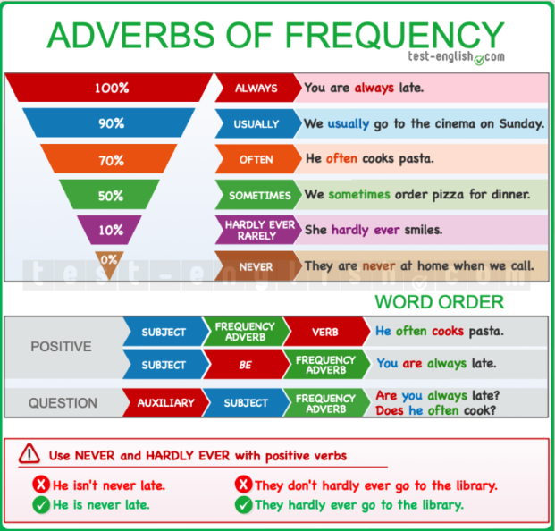***SUMMARY CHART***